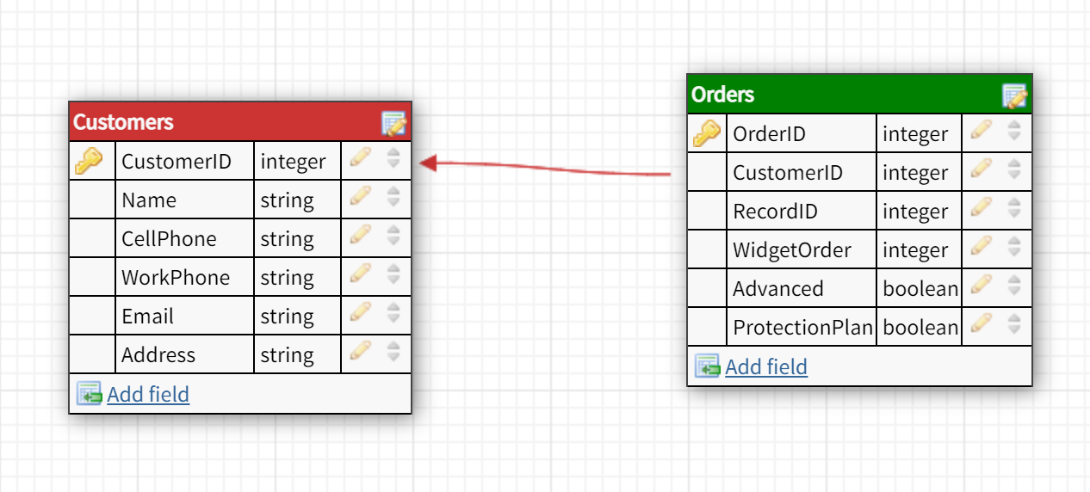

There is only a need for 2 tables. One to maintain customer records, and another to maintain orders. Each order is connected to a customer.

The RecordID should go with orders, as it likely is used to identify specific orders in the old database. Keeping it here allows it to maintain legacy code.

Widget order is the number for the widget. Per the email, either Basic or Advanced will have a value, but not both, so Advanced is a bool to indicate which type of widget is ordered.

Table creation SQL statements:

CREATE TABLE Customers (

CustomerID INT NOT NULL,

Name VARCHAR(255) NOT NULL,

CellPhone VARCHAR (255) NOT NULL,

WorkPhone VARCHAR (255) NOT NULL,

Email VARCHAR (255) NOT NULL,

Address VARCHAR (255) NOT NULL,

PRIMARY KEY (CustomerID)

);

CREATE TABLE Orders (

OrderID int NOT NULL,

CustomerID INT NOT NULL FOREIGN KEY REFERENCES Customers(CustomerID),

RecordID INT NOT NULL,

WidgetOrder INT NOT NULL,

Advanced varchar(255) NOT NULL,

ProtectionPlam varchar(255) NOT NULL,

PRIMARY KEY (OrderID)

);